**Practical No: 5** Ninad Karlekar 22306A1012 Date: 18/04/2023

Aim: Configure and verify path control using PBR (Policy Based Routing).

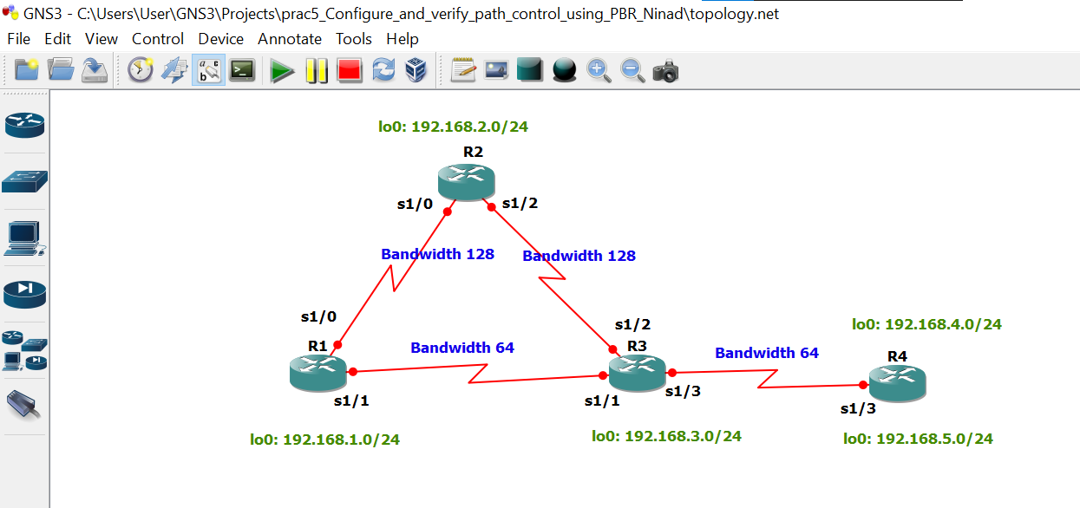

Take 4 routers -> Configure -> slots -> NM-4T

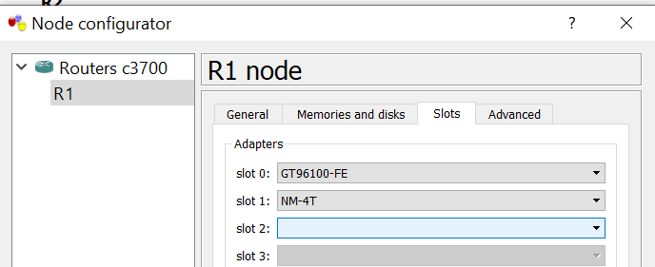

**STEP 1: Perform IP configuration**

**On router 1 console**

R1 # conf t

R1(config) # hostname r1

r1(config) # int s1/0

r1(config-if) # ip add 172.16.12.1 255.255.255.0

r1(config-if) # bandwidth 128

r1(config-if) # no sh

r1(config-if) # int s1/1

r1(config-if) # ip add 172.16.13.1 255.255.255.0

r1(config-if) # bandwidth 64

r1(config-if) # no sh

r1(config-if) # int lo0

r1(config-if) # ip add 192.168.1.1 255.255.255.0

r1(config-if) # do sh ip int br | include up

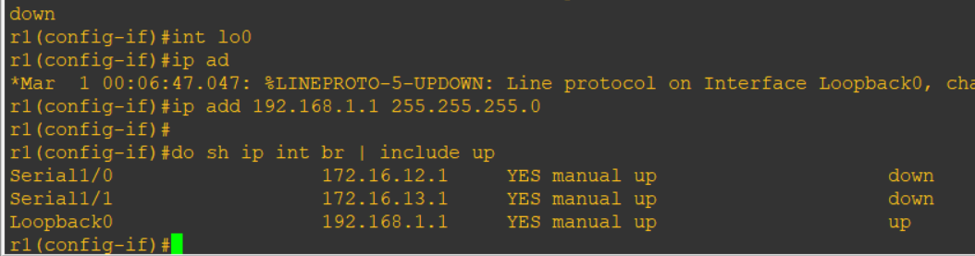

**On router 2 console**

R2 # conf t

R2(config) # hostname r2

r2(config) #

r2(config) # int s1/0

r2(config-if) # ip add 172.16.12.2 255.255.255.0

r2(config-if) # bandwidth 128

r2(config-if) # no sh

r2(config-if) #

r2(config-if) # int s1/2

r2(config-if) # ip add 172.16.23.2 255.255.255.0

r2(config-if) # bandwidth 128

r2(config-if) # no sh

r2(config-if) #

r2(config-if) # int lo0

r2(config-if) # ip add 192.168.2.2 255.255.255.0

r2(config-if) #

r2(config-if) # do sh ip int br | include up

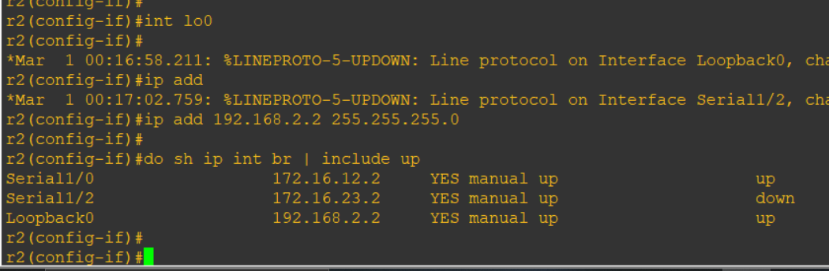

**On router 3 console**

R3 # conf t

R3(config) # hostname r3

r3(config) #

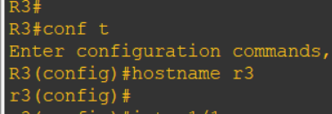

r3(config) # int s1/1

r3(config-if) # ip add 172.16.13.3 255.255.255.0

r3(config-if) # bandwidth 64

r3(config-if) # no sh

r3(config-if) #

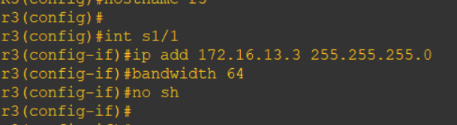

r3(config-if) # int s1/2

r3(config-if) # ip add 172.16.23.3 255.255.255.0

r3(config-if) # bandwidth 128

r3(config-if) # no sh

r3(config-if) #

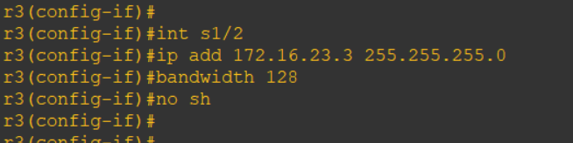

r3(config-if) # int s1/3

r3(config-if) # ip add 172.16.34.3 255.255.255.0

r3(config-if) # bandwidth 64

r3(config-if) # no sh

r3(config-if) # int lo0

r3(config-if) # ip add 192.168.3.3 255.255.255.0

r3(config-if) #

r3(config-if) # do sh ip int br | include up

**On router 4 console**

R4 # conf t

Enter configuration commands, one per line. End with CNTL/Z.

R4(config) # hostname r4

r4(config) #

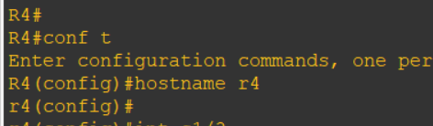

r4(config) # int s1/3

r4(config-if) # ip add 172.16.34.4 255.255.255.0

r4(config-if) # bandwidth 64

r4(config-if) # no sh

r4(config-if) #

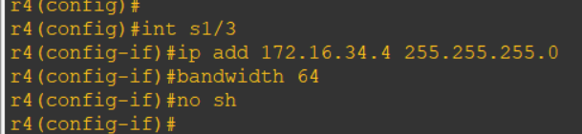

r4(config-if) # int lo0

r4(config-if) # ip add 192.168.4.1 255.255.255.0

r4(config-if) #

r4(config-if) # int lo1

r4(config-if) # ip add 192.168.4.1 255.255.255.0

r4(config-if) # ip add 192.168.5.1 255.255.255.0

r4(config-if) #

r4(config-if) # do sh ip int br | include up

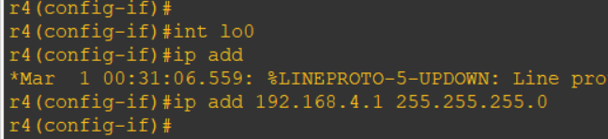

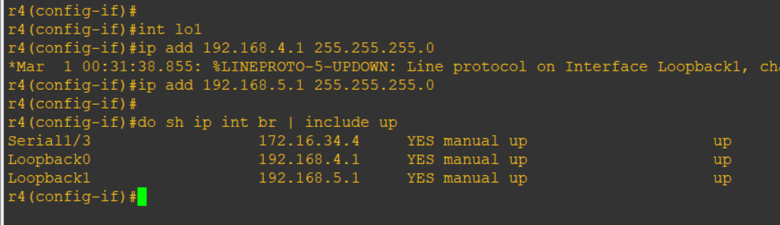

**STEP 2 : Configure eigrp on all routers**

**On router 1 console**

r1(config) # router eigrp 1

r1(config-router) # network 172.16.12.0 0.0.0.255

r1(config-router) # network 172.16.13.0 0.0.0.255

r1(config-router) # network 192.168.1.0

r1(config-router) # no auto-summary

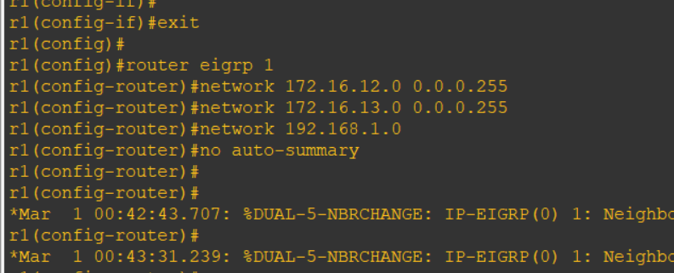

**On router 2 console**

r2(config) # router eigrp 1

r2(config-router) # network 172.16.12.0 0.0.0.255

r2(config-router) #

r2(config-router) # network 172.16.23.0 0.0.0.255

r2(config-router) # network 192.168.2.0

r2(config-router) # no auto-summary

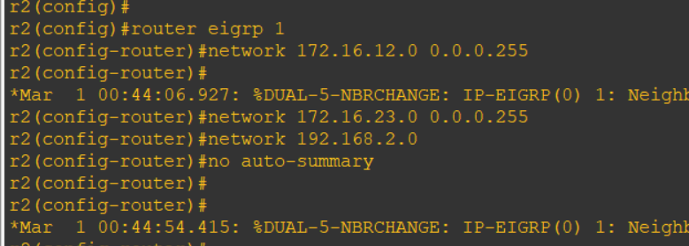

**On router 3 console**

r3(config-if) # router eigrp 1

r3(config-router) # network 172.16.13.0 0.0.0.255

r3(config-router) # network 172.16.13.0 0.0.0.255

r3(config-router) # network 172.16.23.0 0.0.0.255

r3(config-router) # network 172.16.34.0 0.0.0.255

r3(config-router) # network 192.168.3.0

r3(config-router) # no auto-summary

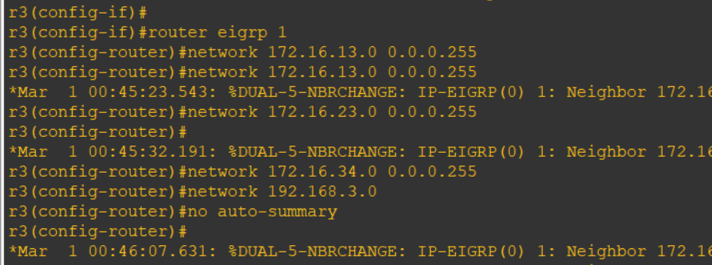

**On router 4 console**

r4(config) # router eigrp 1

r4(config-router) # network 172.16.34.0 0.0.0.255

r4(config-router) #

r4(config-router) # network 192.168.4.0

r4(config-router) # network 192.168.5.0

r4(config-router) # no auto-summary

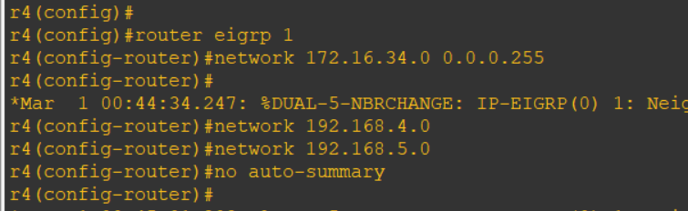

**STEP 3: Command on all routers**

do sh ip route

r4(config) # do ping 192.168.1.1

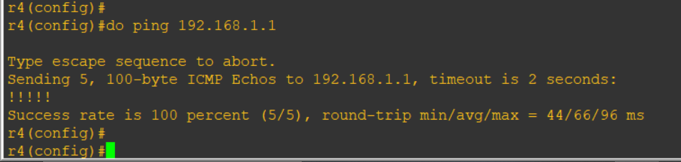

r1(config) # do ping 192.168.4.1

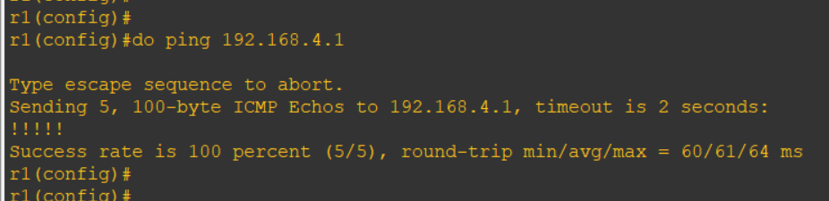

**R4**

r4(config) # do traceroute 192.168.1.1 source 192.168.4.1

r4(config) #

r4(config) # do traceroute 192.168.1.1 source 192.168.5.1

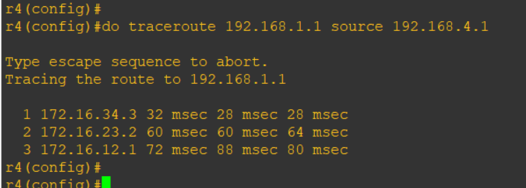

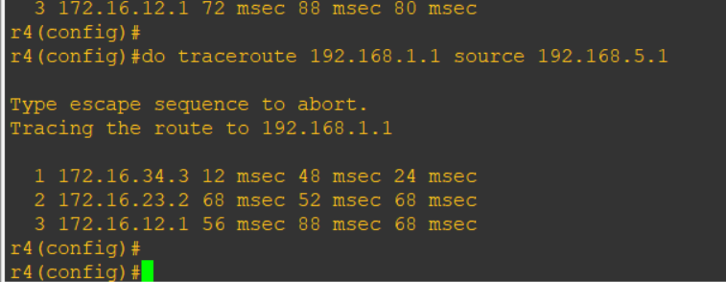

Configure PBR to provide path control

* All traffic from source 192.168.5.1 should take route R4 -> R3 -> R1
* All traffic from source 192.168.4.1 should take route R4 -> R3 -> R2 -> R1

**On router 3 console**

r3(config) # ip access-list standard pbr-acl

r3(config-std-nacl) # permit 192.168.5.0 0.0.0.255

r3(config-std-nacl) # exit

r3(config) #

r3(config) #

r3(config) # route-map r3-to-r1 permit

r3(config-route-map) # match ip address pbr-acl

r3(config-route-map) #

r3(config-route-map) # set ip next-hop 172.16.13.1

r3(config-route-map) # exit

r3(config) #

r3(config) # int s1/3

r3(config-if) # ip policy route-map r3-to-r1

r3(config-if) # end

**On router 4 console**

r4(config) # do traceroute 192.168.1.1 source 192.168.4.1

r4(config) # do traceroute 192.168.1.1 source 192.168.5.1

